**Linux Administration  
Lets Upgrade  
Assignement: 4**

|  |
| --- |
| Assignment 0: 1. Create a simple shell script to tell the user about their session – they need to know:  ● What their username is  ● What the current date is  ● What the time is  ● What their current working directory is  ● How many files they have in that directory  ● What is the biggest file in their current directory |
| Assignment 1: Create a directory with a few test files in it (the files can be empty). Now write a script that for every file in that directory you rename it to have an extension of today's date in YYYYMMDD format. |
| Assignment 2: Write a script that takes a number as an input and reverses it out to the user. For example, if the original number is 74985, the output should be 58947. |

**Assignment 0**

1. **Create a simple shell script to tell the user about their session – they need to know:** - What their username is

* What the current date is
* What the time is
* What their current working directory is
* How many files they have in that directory
* What is the biggest file in their current directory

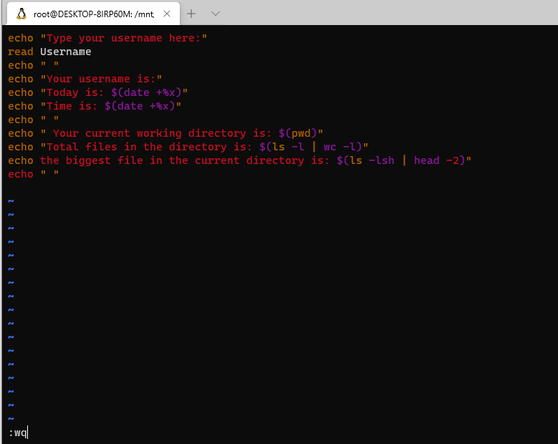

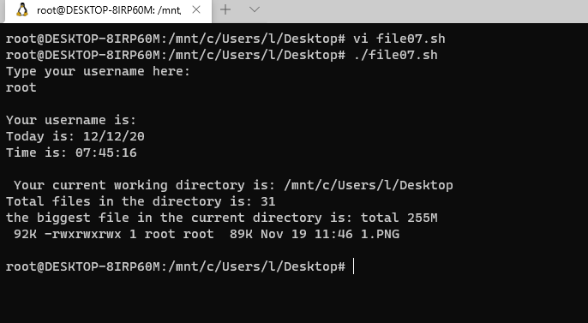

**Assignment 1**

**Create a directory with a few test files in it (the files can be empty). Now write a script that for every file in that directory you rename it to have an extension of today's date in YYYYMMDD format.**

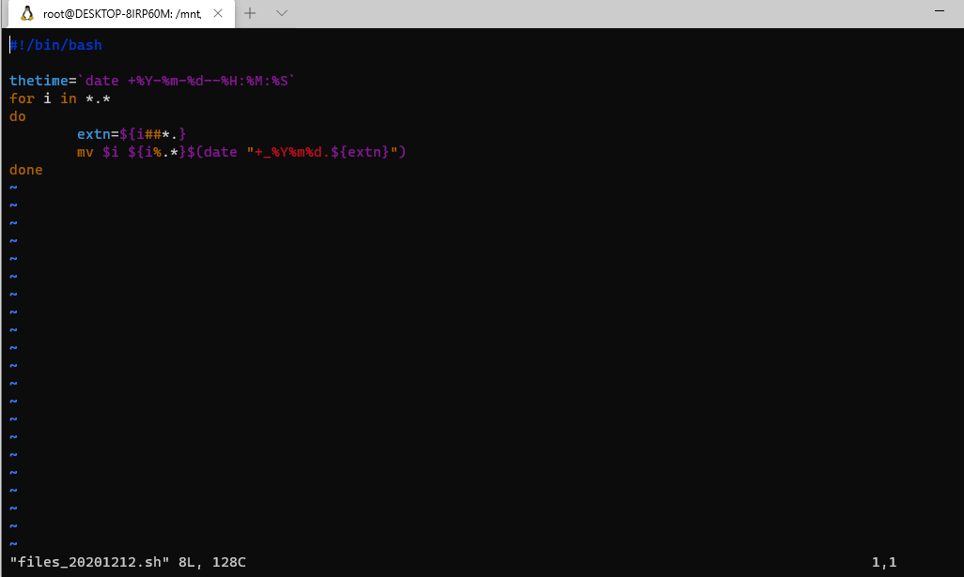

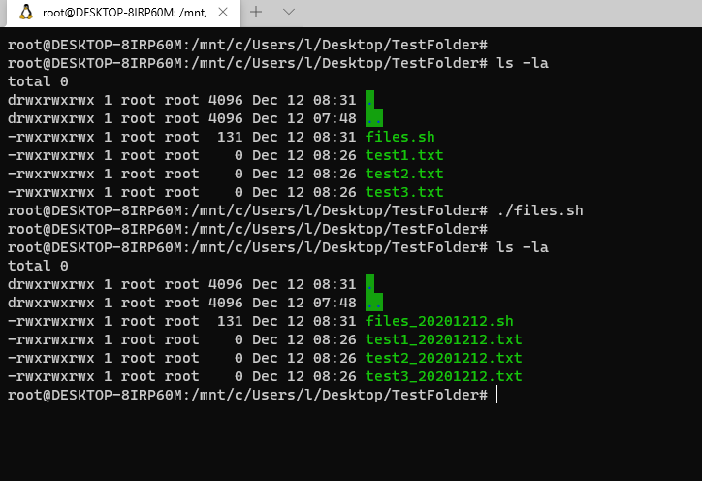

**Assignment 2**

**Write a script that takes a number as an input and reverses it out to the user. For example, if the original number is 74985, the output should be 58947.**

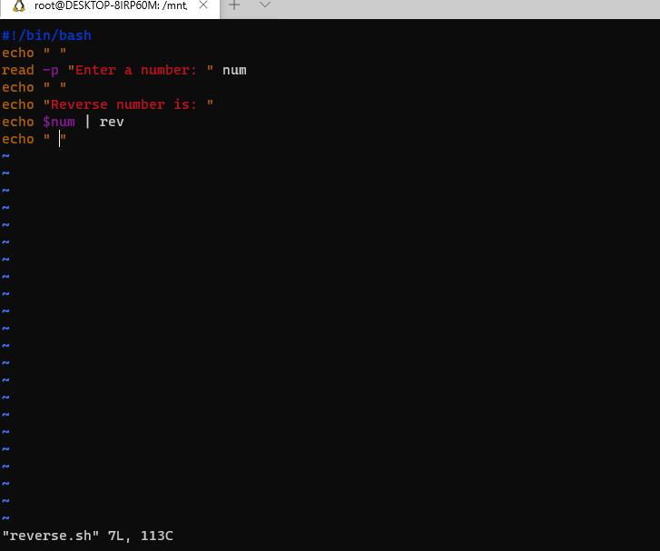

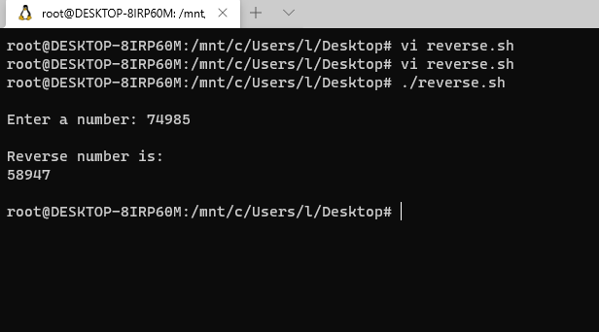

**Assignment 3**

**Write a script to validate how secure someone's password is. Things you would care about:**

* Length should be 8 or more characters
* The password should contain numbers and letters
* There should be both uppercase and lowercase letters

